Week3
July 2025

BACKGROUND
In this activity you will consider the usefulness of some suggested R code, identify data issues, and produce descriptive statistics.
A researcher is interested in the heights and weights of a population of adults, and whether these differ according to whether the adult has an active lifestyle or not and whether adults are left or right-handed. In general, they are interested in any interesting findings that can be found by exploring the dataset.

SUPPORT
There is a supporting video that introduces this exercise, that uses the same data structure but different sample values. This may help you understand the context.
Watch this video on YouTube

LOADING THE DATA
Load the dataset here! Call the dataset ‘content’.
This approach assumes that you have a directory structure with subfolders called ‘data’ and ‘scripts’. The data should be in the ‘data’ folder, and the Rmarkdown file should be saved in the ‘scripts’ folder. This is standard industry good practice for file directory structure. It helps towards the principles of reproducible research if we all follow the same directory structure anyone can run your code.
content <- read.csv("../data/weight_height.csv")

DATA STRUCTURE
The variables collected for a number of adults are: weight – in kilograms height – in centimetres handed - if adult is ‘left’ or right’ handed active - is adult considered to be active? ‘yes’ or ‘no’

Helpful Code
Some useful code is given below. Try it out and see what it does.
# Summary of numeric columns
#summary(content[, sapply(content, is.numeric)], na.rm = TRUE)
# Frequency tables
table(content$handed)
##
## left right unknown
## 85 1320 7
table(content$handed, content$active)
##
## missing no unknown yes
## left 0 55 4 26
## right 2 997 51 270
## unknown 0 6 0 1
# Mosaic plot
mosaicplot(table(content$handed, content$active))
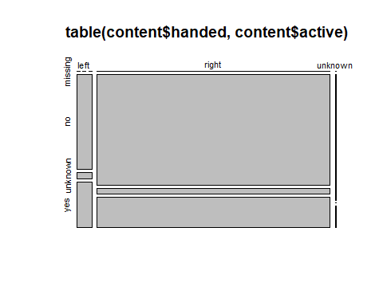
# Summary statistics by handedness
by(content, factor(content$handed), summary)
## factor(content$handed): left
## weight height active handed
## Min. :71.10 Min. :168.1 Length:85 Length:85
## 1st Qu.:76.91 1st Qu.:176.3 Class :character Class :character
## Median :79.14 Median :178.5 Mode :character Mode :character
## Mean :79.36 Mean :178.3
## 3rd Qu.:82.00 3rd Qu.:181.2
## Max. :92.49 Max. :186.4
## ------------------------------------------------------------
## factor(content$handed): right
## weight height active handed
## Min. :11.00 Min. : 0.0 Length:1320 Length:1320
## 1st Qu.:77.28 1st Qu.: 175.6 Class :character Class :character
## Median :79.86 Median : 178.6 Mode :character Mode :character
## Mean :79.70 Mean : 180.0
## 3rd Qu.:82.22 3rd Qu.: 181.6
## Max. :92.89 Max. :1792.4
## ------------------------------------------------------------
## factor(content$handed): unknown
## weight height active handed
## Min. :76.78 Min. : 2.0 Length:7 Length:7
## 1st Qu.:77.19 1st Qu.:170.0 Class :character Class :character
## Median :80.21 Median :173.1 Mode :character Mode :character
## Mean :79.88 Mean :149.0
## 3rd Qu.:81.94 3rd Qu.:175.6
## Max. :83.91 Max. :176.8
# Proportions of handedness
prop.table(table(content$handed))
##
## left right unknown
## 0.060198300 0.934844193 0.004957507
# Replace "unknown" with NA in 'handed'
content$handed[content$handed == 'unknown'] <- NA
# Replace extreme weight values with NA
content$weight[content$weight > 250] <- NA
# Count of non-missing weight values
length(na.omit(content$weight))
## [1] 1412
# Aggregated height statistics by handedness and activity
agg<- aggregate(
height ~ handed + active,
data = content,
FUN = function(x) c(mean = mean(x), sd = sd(x))
)

Preliminary exploratory data analyses.
Adapting the above code, or otherwise, prepare some summary statistics for the attached data.
Consider what this reveals about any issues with the raw data, and further data preparation that may be required prior to statistical analyses. List those issues here.

Data Cleaning
Apply any further data preparation that may be required prior to statistical analyses, to ensure that only valid observations will be included in future analyses.

Exploratory data analyses using only the valid observations.
Produce summary statistics using only the valid observations. You may wish to consider for example:
How many adults in the sample are active?
What is the best estimate for the proportion of adults in the population that are active?
How many active adults in the sample are right-handed?
How many valid observations are there for weight?
What is the sample minimum weight?
What is the sample maximum weight?
What is the sample mean weight?
What is the sample standard deviation for weight?
What is the sample minimum weight of the active adults?
What is the sample maximum weight of the active adults?
What is the sample mean weight of the active adults?
What is the sample standard deviation weight of the active adults?

Conclusions
Offer some interpretation. Some examples of research questions you may want to answer are:
How do active adults compare to non-active adults in terms of weight and height?
How does the average and variability of weight and height differ by handedness?

